Student name: yizheng he

Student ID: 221411294

SIT123: Data Capture Technologies

# Lab Work Week 2.1:

# Getting started with Sensors (30 marks)

In this task, we will attach sensors to the Arduino board, and collect sensor data. Similar to last week, we will use software engineering methods to plan and organize our exercise.

## Due Date Friday 8:00pm, Week 3 – 29th July 2022

## Hardware Required

* Arduino Board
* USB cable
* HCSR505 PIR (Passive Infra Red) Motion Detector
* DHT22 Temperature and Humidity Sensor
* DFrobot Soil Moisture Sensor
* Male to Female Dupont Jumper Wires
* Male to Male Dupont Jumper Wires

## Software Required

Arduino programming environment

## Pre-requisites: You must do the following before this task

1. **Attend Class (Lecture)**
2. **Read this sheet from top to bottom**

## Task Objective

**For this task, your tutor/lecturer will be your client. Here are your client’s requirements:**

* **“We have an Arduino board and some sensors. We need to be able to measure air temperature, humidity, motion, and soil moisture, and see the collected data in real-time on the computer screen.”**

## Task Submission Details

There are 4 questions in this task. Answer all of them in this word document itself and submit to unit site.

### **Q1: Consider the given Task Objective. Think about how this simple system can be decomposed to ‘Sense-Think-Act’ as discussed in class (lecture).**

1. What is the ‘sensing’ requirement in this system, if any?

Motion Dectector: whether the object is moving.

Temperature and Humidity: Detects the temperature of the surrounding area or object

Soil Moisture: Detection of humidity

1. What is the ‘thinking’ requirement in this system, if any?

Motion detector. When motion is detected, the data is recorded and the LED lights up and then turns off. If no motion is detected, data is recorded and the LED does not glow.

Temperature: touch or get close to surrounding objects to record

Soil moisture: Check soil moisture, here use wet wipes instead, record soil.

1. What is the ‘acting’ requirement in this system, if any?

(3 marks)

measure motion: When movement is detected, the LED lights light up, recording the data

temperature: When the ambient temperature is detected, the data is recorded.

Soil moisture: Check soil moisture, here use wet wipes instead, record soil.

### **Q2: PIR Motion Detector**

Please refer to the provided ‘**Sensing Motion Activity Sheet**’ and follow the steps.

1. Refer to the given code in HCSR505motion.ino. What does the following line mean?

Serial.begin(9600);

Enables the Arduino to exchange information with the serial monitor at a data rate of 9600 bits per second.

(1 mark)

1. If the Arduino transfers data at 4800 bits per second and you're sending 12 bytes of data, how long does it take to send over this information?

(2 marks)

12 *8 =96, 96/4800 = 0.02second

c) What is a simple strategy to test this program to make sure it is working as given in the requirements?

(1 mark)

Observe whether the serial port monitor shows active or inactive

1. Take a screenshot of your Serial Monitor displaying motion data logs. Add the image here.

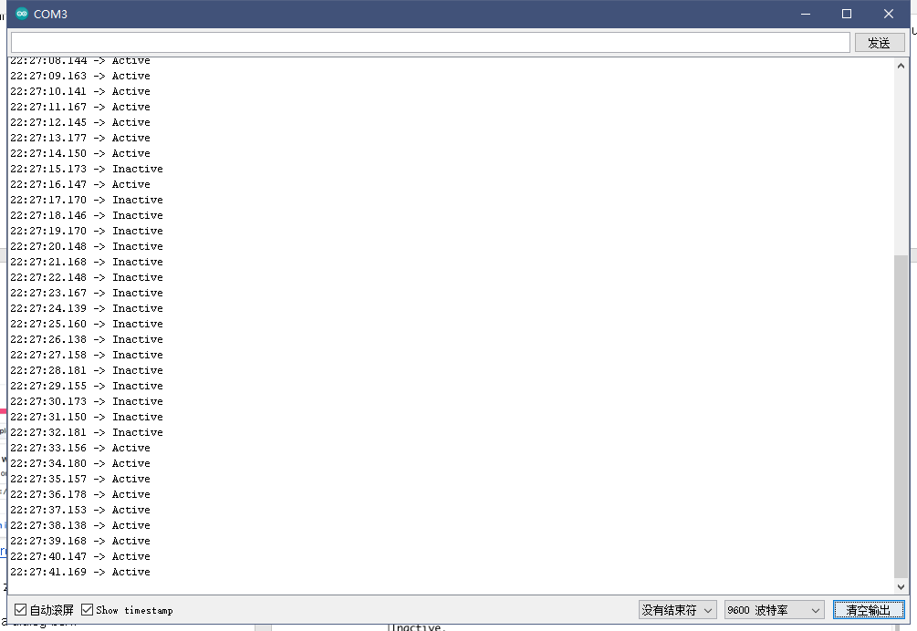

(2 marks)

e) Run your program for three minutes. In that time, make sure the sensor can detect ‘Active’ as well as ‘Inactive’ data by creating some movement for it to detect. Retrieve the collected data as text file and save it your computer’s hard drive, naming it ‘lab2_motionData.txt’. Upload ‘lab2_motionData.txt’ with this lab report.

(3 marks)

### **Q3: Temperature and Humidity Sensor**

1. Please refer to the provided ‘**Sensing Temperature and Humidity Activity Sheet**’ and follow the steps. Consider the given code in the activity sheet and fill the table below. The first row is completed for you.

|  |  |  |
| --- | --- | --- |
| term | explanation | example usage from code |
| variable | A variable is a place to store a piece of data. It has a name, a value, and a type. | float temp; |
| library | Arduino supports extensions using libraries, which provide additional functionality for use in sketches, from Sketches > Include Libraries > Add.zip Library. | #include <DHT.h>  #include <DHT_U.h> |
| comment | Use the // symbol followed by the code you want to comment on, and enter the comment after it. The statement after // is not compiled by the compiler | // put your setup code here, to run once: |

(2 marks)

b) A spec of the DHT22 sensor is given in the link below. It mentions that the sampling rate is 0.5 Hz.

<https://lastminuteengineers.com/dht11-dht22-arduino-tutorial/>

* 1. What does the sampling rate mean?

It is defined as the sample data per second when the digital signal is collected from the analog audio signal.

* 1. Where is this used in the Arduino code?

delay(2000);

(2 marks)

1. What is a simple strategy to test this program to make sure it is working as given in the requirements?

Observe whether the temperature and humidity are displayed in the serial monitor. (1 mark)

1. Take a screenshot of your Serial Monitor displaying temperature & humidity sensor data logs. Add the image here.

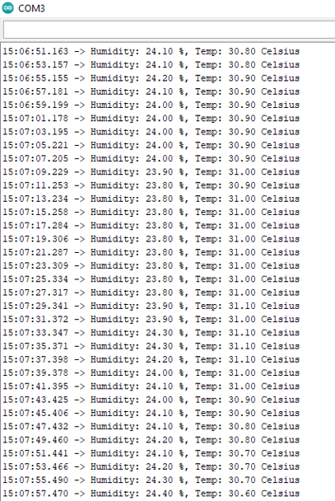

(2 marks)

e) Run your program for five minutes. Retrieve the collected data as text file and save it your computer’s hard drive, naming it ‘lab2_temperatureData.txt’. Upload ‘lab2_temperatureData.txt’ with this lab report.

(4 marks)

### **Q4: Soil Moisture Sensor**

Please refer to the provided ‘**Sensing Soil Moisture Activity Sheet**’ and follow the steps.

1. Refer to the given code in DFRobotSoilMoisture.ino. What does the following line do?

val = analogRead(0);

**connect sensor to Analog 0**

(1 mark)

1. How is analogRead different than digitalRead?

digitalRead() is generally used to switch either high or low (1 or 0, on or off). analogRead(). -Reads an analog pin and returns an integer between 0 and 1023 or tells us the brightness or speed.

[Hint: we used digitalRead in the code for HCSR505 PIR Motion detector]

(1 mark)

1. What is a simple strategy to test this program to make sure it is working as given in the requirements?

Observe whether the humidity is displayed in the serial monitor

(1 mark)

1. Take a screenshot of your Serial Monitor displaying soil moisture sensor data logs. Add the image here.

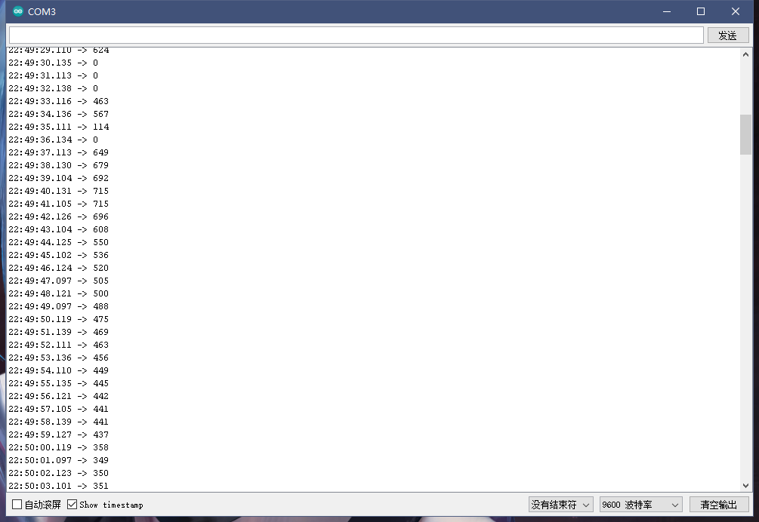

(2 marks)

e) Run your program for three minutes. Experiment testing the sensor in the air, in water & wet tissue. Retrieve the collected data as text file and save it your computer’s hard drive, naming it ‘**lab2_soilMoistureData.txt**’. Upload ‘**lab2_soilMoistureData.txt**’with this lab report.

(2 marks)

**Important: When you are finished, gently unplug the jumper cables from the Arduino pins and the sensor pins.**